MEDICAL CARE COSTS STORY

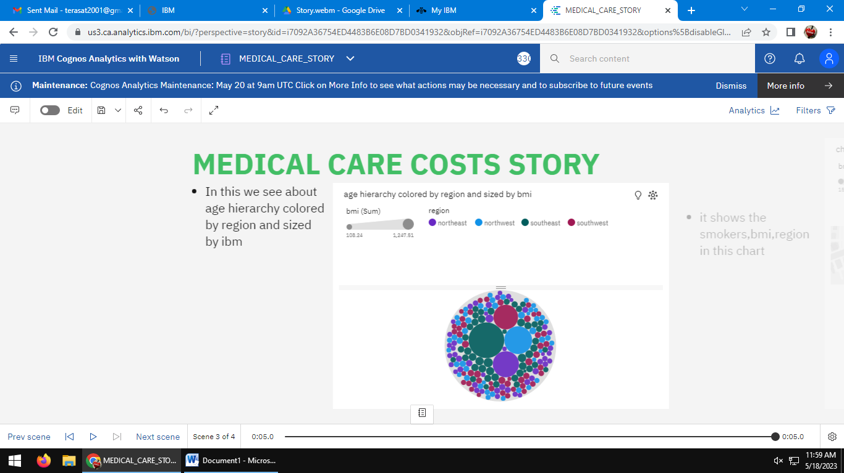

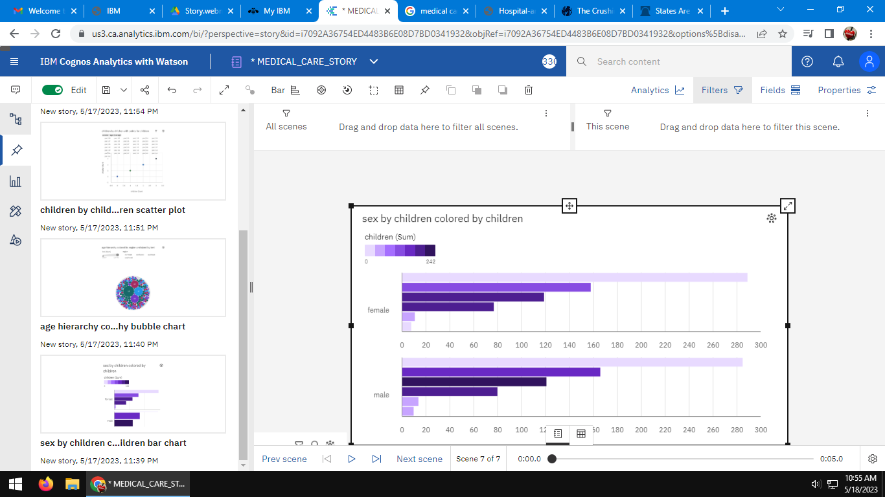

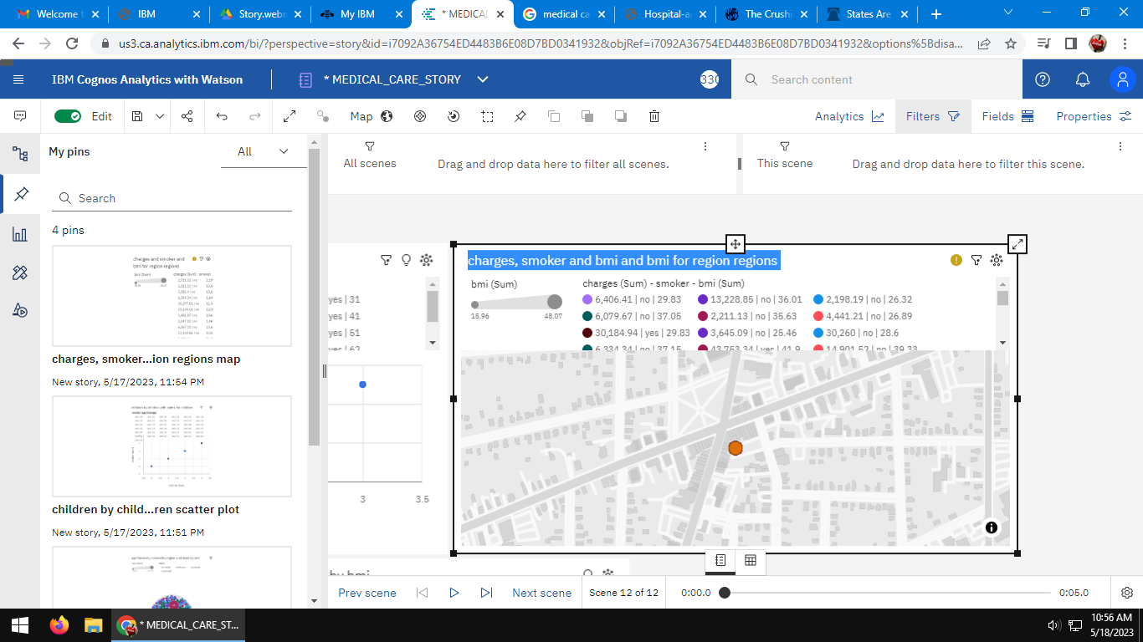

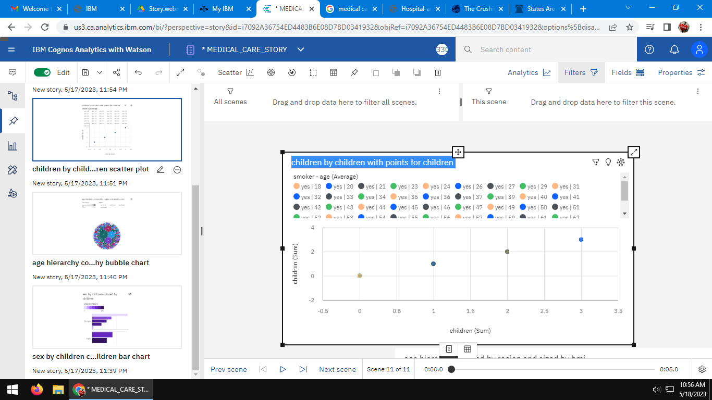

LINK OF STORY:

<https://us3.ca.analytics.ibm.com/bi/?perspective=story&pathRef=.my_folders%2FMEDICAL_CARE_STORY&action=view&sceneId=model000001882d454793_00000000&sceneTime=5000>